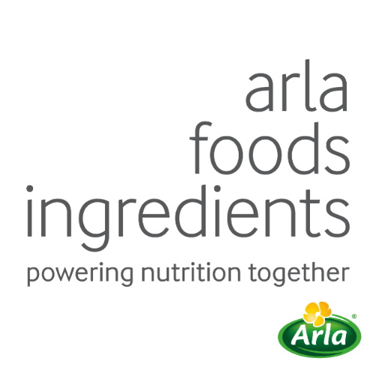

24th May 2023

PRESS RELEASE

New alpha-rich ingredient offers
key to low-protein infant formula

Arla Foods Ingredients has launched a new alpha-lactalbumin-rich infant formula ingredient, helping meet the growing need for low-protein formulations.

Multiple studies have shown that high protein intake during infancy accelerates weight gain, increasing the risk of obesity in later life. Driven by such evidence, and regulatory changes, the protein content of infant formula has gradually fallen in many countries.

One of the most effective ways to create formulas that are lower in protein but high in nutritional quality is to formulate with alpha-lactalbumin (alpha). Rich in essential amino acids and high in other amino acids, such as cysteine, it is the most abundant whey protein in human milk, but standard formula contains considerably lower levels.
Arla Foods Ingredients’ newest whey protein isolate, Lacprodan® ALPHA-50, presents a new solution to this challenge. Alpha-lactalbumin accounts for a minimum of 90% of its protein content, which means smaller dosages can be used to reach a level similar to that of human milk.
The new product’s high level of alpha-lactalbumin allows a high degree of formulation freedom. For example, it can be combined with other functional ingredients, such as Lacprodan® MFGM-10, a milk fat globule membrane ingredient which contains compounds such as phospholipids, sphingomyelin and gangliosides.

Lone Strøm, Head of Paediatric Sales Development at Arla Foods Ingredients, said: “Lacprodan® ALPHA-50 offers solutions to two big challenges facing formula manufacturers. Its high alpha-lactalbumin content allows the creation of products that are lower in protein, demand for which is growing because of concerns about obesity. And because it delivers considerable amounts of essential amino acids, even at a low dosage, it is easily combined with other ingredients that are sought after in formula.”

The new product is the latest addition to Arla Foods Ingredients’ alpha range. Other products include Lacprodan® ALPHA-06, a whey protein concentrate that is high in alpha-lactalbumin, and Lacprodan® ALPHA-10, which is supported by both clinical documentation and 25 years of market use.

The latest clinical research on alpha-lactalbumin will be explored in a virtual seminar, ‘Discover the wonders of Alpha’, at the end of September.

Arla Foods Ingredients supports the WHO recommendation for exclusive breastfeeding for the first six months of an infant’s life and continued breastfeeding up to the age of two or beyond in combination with nutritionally appropriate complementary foods.

For more information contact:
Steve Harman, Ingredient Communications
Tel: +44 (0)7538 118079 | Email: steve@ingredientcommunications.com

About Arla Foods Ingredients
Arla Foods Ingredients is a global leader in improving premium nutrition. Together with our customers, research partners, suppliers, NGOs and others, we discover and deliver documented ingredients and products that can advance lifelong nutrition for the benefit of consumers around the world.

We serve leading global brands in early life nutrition, medical nutrition, sports nutrition, health foods, and other foods and beverages.

Five reasons to choose us:
- We're passionate about improving nutrition
- We innovate by connecting the best
- We master both discovery and delivery
- We build strong, long-lasting partnerships
- We are committed to sustainability

Headquartered in Denmark, Arla Foods Ingredients is a 100% owned subsidiary of Arla Foods.

LinkedIn
http://www.linkedin.com/company/arla-foods-ingredients

LinkedIn (Latin America)
https://www.linkedin.com/showcase/arla-foods-ingredients-latin-america/

LinkedIn (China)
https://www.linkedin.com/showcase/arla-foods-ingredients-china/

Koletzko et al, 2009, Weber et al, 2014, Totzauer et al, 2022
Lönnerdal et al, 2017
Sandström et al 2008; Nilsson et al 2023

